

FWA Change Order – 115, 116, 118, 119, 120, 121, 122, 123

In Specification

Release Note

www.projectobjects.com

support@projectobjects.com

Contents

FWA Chnage Order, “Approver” field Logic 3

FWA Change order, “created by” field logic 4

FWA Change order, “BY” Field logic 5

fwa Change order, “C.O. E&C authorization date” Field logic 6

fwa change order automatic data filling from omnia (stage table) 7

fwa change order, “% C.O. Increase vs Base Amount” field logic 8

FWA change order, “% C.O. Increase vs Overall Amount” field logic 10

fwa change order, “Estimated Amount for Authorization Threshold” field logic 11

## FWA Chnage Order, “Approver” field Logic

Overview:

In this release, we have implemented an **“Approver”** field logic for **FWA Change Order** form and made this field editbale for 1st and 2nd step of workflow.

Form Details:

* **Approver** field would be editable only for 1st and 2nd step of workflow.
* Users of **FWA CO Approver** group will be visible in the **Approver** field.

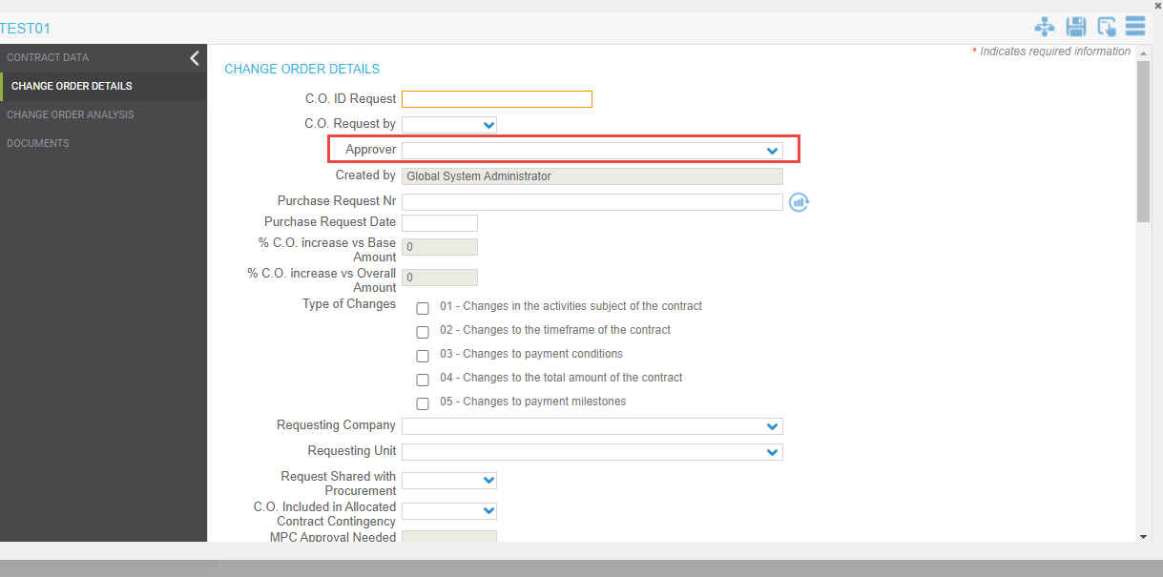

Functionality Details:

* We have added a **Approver** field in the workflow module. User of selected group in this field will be visible in the **Approver** field of **FWA Change Order** form.

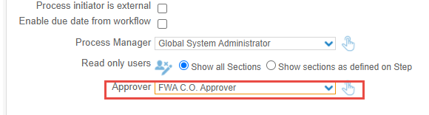

* Users of the FWA C.O Approver group will be visible in the Approver field of FWA Change Order form.

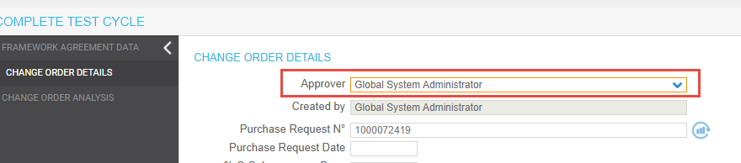

* User selected in the **Approver** field is also a approver of step 3 of workflow.
* We have made **Approver** field editable in **1st** and **2nd** step of workflow.

## FWA Change order, “created by” field logic

Overview:

In this release, we have implemented some changes in the **“Created By”** field. Now **“Created By”** field will show the full name of the user who has created the **FWA Change Order** form.

Form Details:

* We have removed the drop-down from the **“Created By”** field.
* We have made the **“Created By”** field non-editable.

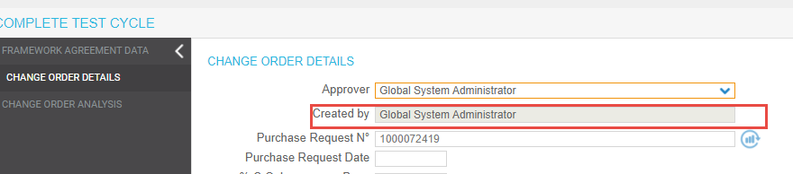

Functionality Details:

When a user creates **FWA Change Order** object, then the **“Created By”** field will automatically fill with the **User Full Name** who has created the object.

If another user makes any changes in the **FWA Change Order** form and clicks on the save/apply icon. Then there will be no change in the data of the **“Created By”** field and it will show the **User Full Name**, who has created the **FWA Change Order** object.



## FWA Change order, “BY” Field logic

Overview:

In this release, we have implemented the changes for the **By** field. We have made this field non-editable and this field will show the Full Name of user who will release the **FWA Change Order** object from step 3 to step 4 of workflow.

Form Details:

* This field will be blank before the release from the 3rd step.
* This field is non-editable always.

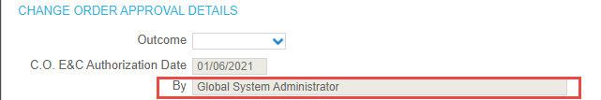

Functionality Details:

* The **By** field will be blank in the 1st, 2nd and 3rd step.
* When the user will release the form from the 3rd then the **By** field will be updated with the full name of user who has released the form from 3rd step to 4th step and remain non-editable.



## fwa Change order, “C.O. E&C authorization date” Field logic

Overview:

In this release, we have implemented the changes for the **C.O. E&C** **Authorization Date** field. We have made this field non-editable and this field will show the date of release of the **FWA Change Order** object from step 3 to step 4 of workflow.

Form Details:

* This field will be blank before the release from the 3rd step.
* This field is non-editable always.

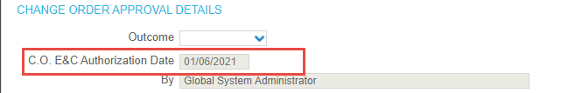

Functionality Details:

* The **Authorization Date** field will be blank in the 1st, 2nd and 3rd step.
* When the user will release the form from the 3rd step then the **C.O. E&C** **Authorization Date** field will be updated with the date of release of **FWA Change Order** form from 3rd step to 4th step and remain non-editable.



## fwa change order automatic data filling from omnia (stage table)

Overview:

In this release, we have implemented a functionality to retrieve data from **STAGE TABLE** to **FWA Change Order** form when **Purchase Request Number** is **entered in form. We have also implemented the auto update data in FWA Change Order form from Stage** Table in every 24 hours.

Form Details:

* We have implemented a update icon adjacent to **Purchanse Request Nr** field.
* Data will be imported in the **Issued C.O. Amount and Equivalent Amount (€) field.**
* We have made these fields non-editbale manually.

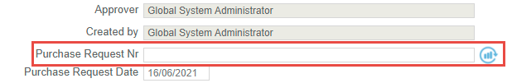

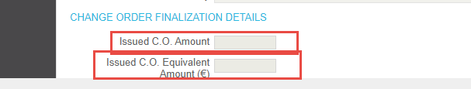

Functionality Details:

* When a user enters a Purchase Request Number in FWA Change Order form and click on the update icon adjacent to the Purchase Request Nr, then data will be retrieved in the **Issued C.O. Amount and Equivalent Amount (€) field.**

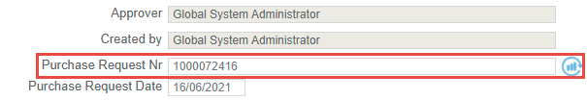

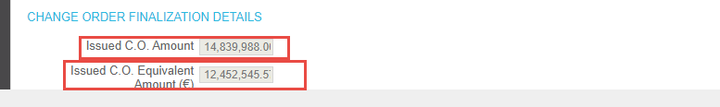

* We have made these fields non-editable manually.
* We have also implemented a job to auto update data in **FWA Change Order** form **from Stage** Table in every 24 hours.

## fwa change order, “% C.O. Increase vs Base Amount” field logic

Overview:

In this release, we have implemented a data calculation logic for the field **“% C.O. Increase Vs Base Amount”**. Now in this field data will be calculated automatically.

Form Details:

* By default, 0 will be visible in this field.
* This field is manually non editable.

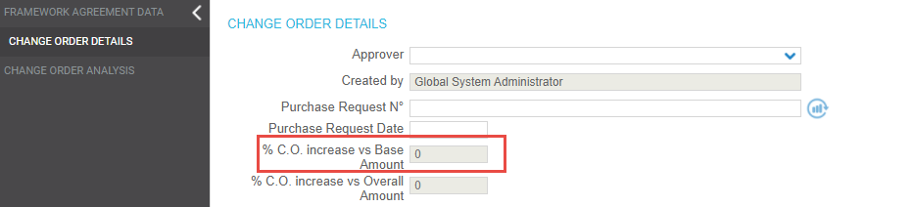

Functionality Details:

Data in this field is calculated with the following logic:

**(Total Change Order Amount (from this Form) / "FA Base Amount" (from this Form)) * 100**

**Total Change Order Amount** field is in **FWA Change Order** form.

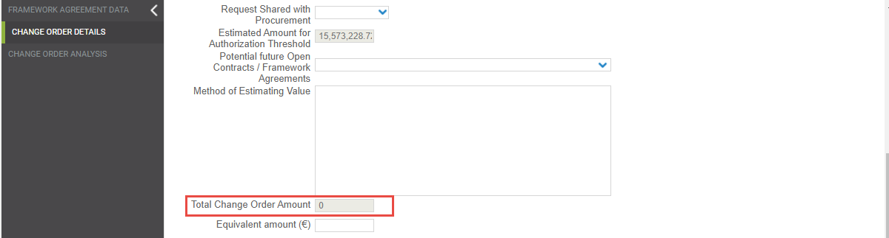

**FA Base Amount** field is in **FWA Change Order** form.

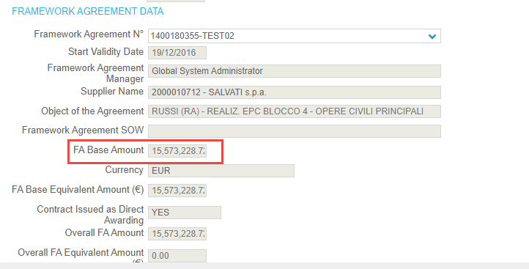

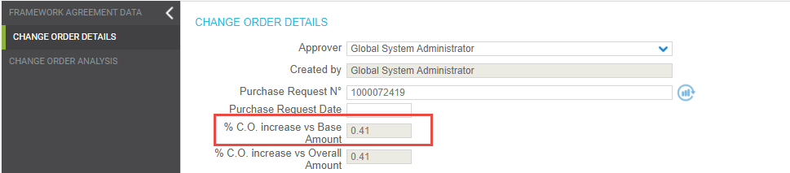

## FWA change order, “% C.O. Increase vs Overall Amount” field logic

Overview:

In this release, we have implemented a data calculation logic for the field **“% C.O. Increase Vs Overall Amount”**. Now in this field data will be calculated automatically.

Form Details:

* By default, 0 will be visible in this field.
* This field is manually non editable.

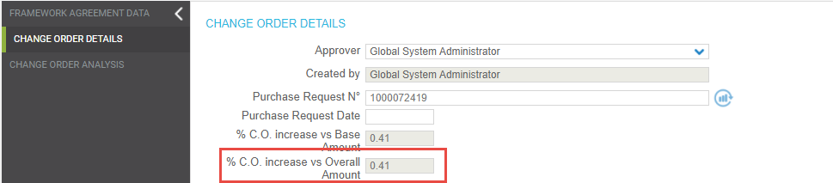

Functionality Details:

Data in this field is calculated with the following logic:

**(Total Change Order Amount (from this Form) / "Overall FA Amount" (from this Form)) * 100**

**Total Change Order Amount** field is in **FWA Change Order** form.



**Overall FA Amount** field is in **FWA Change Order** form.

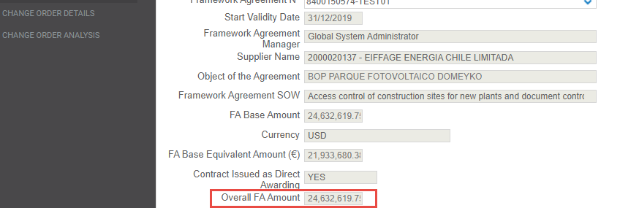



## fwa change order, “Estimated Amount for Authorization Threshold” field logic

Overview:

In this release, we have implemented a data calculation logic for the field **“Estimated Amount For Authorization Threshold”**. Now in this field data will be calculated automatically.

Form Details:

* By default this field will be blank.
* This field is manually non editable.

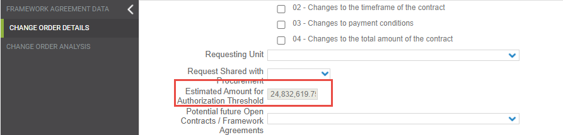

Functionality Details:

Data in this field is retrieved with the following logic:

1. if Field "**Contract issued as Direct Awarding"** is **NO**

Formula:

"**Issued C.O. Amount" + "Total Change Order Amount" (this C.O.Form)**

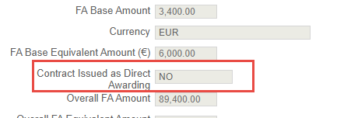

**Issued C.O. Amount** in **FWA Change Order Form:**

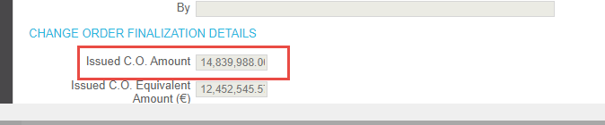

**Total Change Order Amount** in **FWA Change Order Form:**

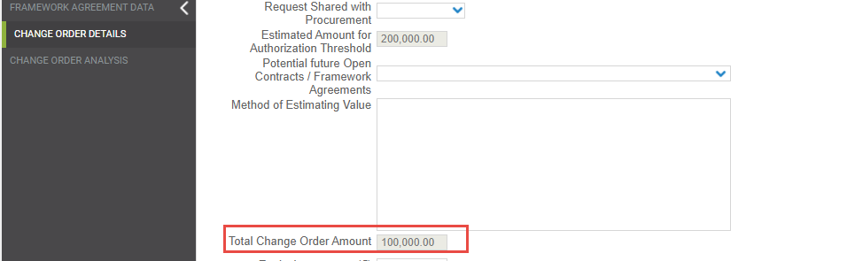



1. if Field "**Contract issued as Direct Awarding"** is **Yes**

Formula:

"**Issued C.O. Amount" + "Total Change Order Amount" (this C.O.Form) + “FA Base Amount”**

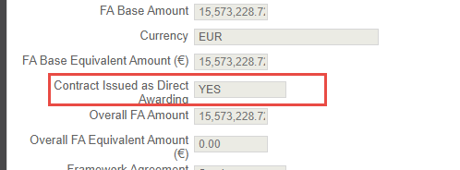

**FA Base Amount** in **FWA Change Order Form:**





 